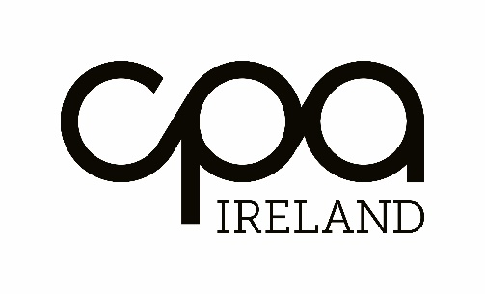

Audit Planning Letter

October 2016

Sample Audit Planning letter

The Board of Directors
XYZ Limited
30 Pembroke Street
Dublin

Date

Re: Audit planning letter

Dear Sirs,

We are writing in connection with the audit due to start on ……… Further to our meeting we now set out below some matters in relation to our audit planning.

At this point we aim to ensure that there is a mutual understanding of the audit and the respective responsibilities of the auditors and the directors.

In addition to providing our formal audit report on your financial statements, we will communicate in our audit findings letter those matters, which we believe to be relevant to the directors that come to our attention as a result of the performance of our audit of the financial statements.

Independence and objectivity

In accordance with the FRC Ethical Standards we as auditors must ensure that our independence and objectivity is maintained at all times.

The following issues are potential threats to our independence:

a.

b.

c.

We have introduced the following safeguards to counter these potential threats.

a.

b.

c.

We confirm that, in our professional judgement and having regard to the safeguards in place, the firm is independent within the meaning of the FRC’s Ethical Standards and the objectivity of the audit engagement partner and staff is not impaired. Therefore, we are pleased to proceed in accordance with our appointment.

Nature and scope of the audit

We set out below an outline of the nature and scope, including where relevant, any limitations thereon, of the work we propose to undertake and the form of the report we expect to make.

We have a statutory responsibility to report to the members/shareholders whether in our opinion the statutory financial statements give a true and fair view of the assets, liabilities, and financial position of the company at the year/period end and of the profit and loss for the year/period then ended and have been properly prepared in accordance with Irish GAAP and the requirements of the Companies Act 2014.

We are required to report the following matters;

- whether adequate accounting records were sufficient to permit the financial statements to be readily and properly audited.
- whether the financial statements are in agreement with the accounting records.
- whether we have obtained all the information and explanations which we think necessary for the purpose of our audit;
- whether the information in the directors' reports is consistent with the financial statements.

In addition, there are certain other matters which according to the circumstances, may need to be dealt with in our report. For example, where the statutory financial statements do not give full details of directors' remuneration or of transactions with the company as specified S.305 to S.312 of the Companies Act 2014.

We will express an unqualified opinion when the financial statements give a true and fair view in accordance with the financial reporting framework. Any modification to this unqualified audit opinion will be expressed in our auditor’s report and in the audit findings letter.

We will conduct our audit in accordance with the International Standards on Auditing (UK and Ireland) issued by the FRC. An audit includes an examination on a test basis of evidence relevant to the amounts and disclosures in the financial statements.

We will also document the internal controls and the systems of your company. We will review internal and external operational, financial, compliance and other risks facing the company, which might affect the financial statements, including the likelihood of those risks materialising and how they are managed.

We will also document and review the control environment within the company, including the attitude of management to controls and whether management have a process for keeping under review the effectiveness of the system of internal control and, where a review of the effectiveness of internal control has been carried out and the results of that review.

We will also review the actions that the directors’ plan to take in response to matters such as developments in law, accounting standards and other developments relevant to the Company’s financial statements.

Findings from the audit

At the end of the audit we will draft an audit findings letter for the attention of the directors’ of the company.

The audit findings letter will include our views and comments on the following:

- Weaknesses in the internal control and accounting systems
- Significant audit risks that have an impact on the audit report
- Unadjusted misstatements
- VAT/PAYE issues Qualitative aspects of the company’s accounting practices and financial reporting
- Matters specifically required by other ISAs (UK and Ireland) to be communicated to the directors’
- Any other audit matters of governance interest.

This letter was prepared for the sole use of the company, the content must not be disclosed to any third party, without our prior written consent and we assume no responsibility to any other person.

Yours faithfully,

Auditors

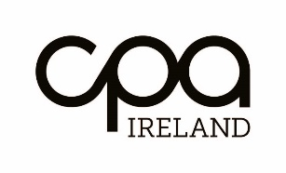

The Institute of Certified Public Accountants in Ireland | The Institute of Certified Public Accountants in Ireland
17 Harcourt Street, Dublin 2, Ireland, D02 W963 | Unit 3, The Old Gasworks, Kilmorey Street, Newry, Co. Down Northern Ireland BT34 2DH
T 01 425 1000 | T 028 305 50000
F 01 425 1001
cpa@cpaireland.ie www.cpaireland.ie

