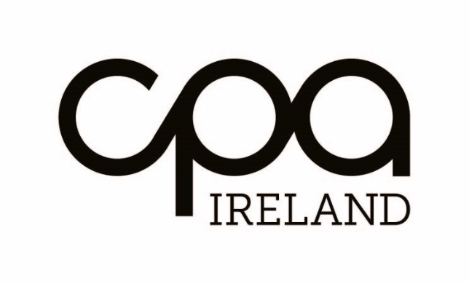

Technical Publications Order Form

Name: |  | Membership ID:
Firm Name:

Email:

Address:

Telephone |  | Date:

Publication | Quantity | Price | *P&P | Total
Clarified Audit Procedures – Paper Version |  | €28 | *€9.50

*If you purchase more than one paper pack an overnight courier service can be provided @ €18.00 per delivery. Please add this to amount instead of the P&P.

Payment method (made payable to CPA Institute):
Note: If purchasing via credit card/laser, we will contact you regarding making your payment.

Signature: Date:

Please complete the order form and return it with appropriate fees to:
Professional Standards Department,
Institute of Certified Public Accountants,
17 Harcourt Street,
Dublin 2.
D02 W963
Tel: 01 425 1040

