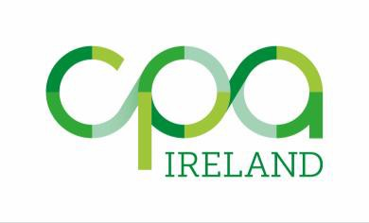

Notice of CPA Ireland
Annual General Meeting

Notice has been hereby given that the 79th Annual General Meeting of Members will be held on Wednesday 27 April 2022 at the Institute of Certified Public Accountants in Ireland, Clonmell House,17 Harcourt Street, Dublin 2, at 4.30pm, to transact the following business:

- To receive the report of the Directors and the Financial Statements for the Year Ended 31 December 2021 and the Auditor’s Report thereon.

- To announce results of Election to Council.

- To appoint the Auditor.

- To authorise the Council to fix the remuneration of the Auditor.

- To transact any other ordinary business of the Institute.

By Order of Council.

Signed: -
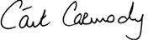

Cáit Carmody Secretary.

5 April 2022

17 Harcourt Street, Dublin 2, D02 W963 +353 (0) 1 425 1000 cpa@cpaireland.ie cpaireland.ie

The Institute of Certified Public Accountants in Ireland (CPA Ireland) is a company limited by guarantee.
Registered office as above. Company No. 010475 (Ireland).

